Data Structure

Sheet #10

Heaps:

1. What is the time complexity of all the operations of the heap-based PQ?. Compare it with list-based implementations (unordered list and ordered list).
2. Explain the meaning of heap-order and complete binary tree properties.
3. Which of the following is a Min-heap and which is a Max-heap? List the names of the operations of the max-heap.

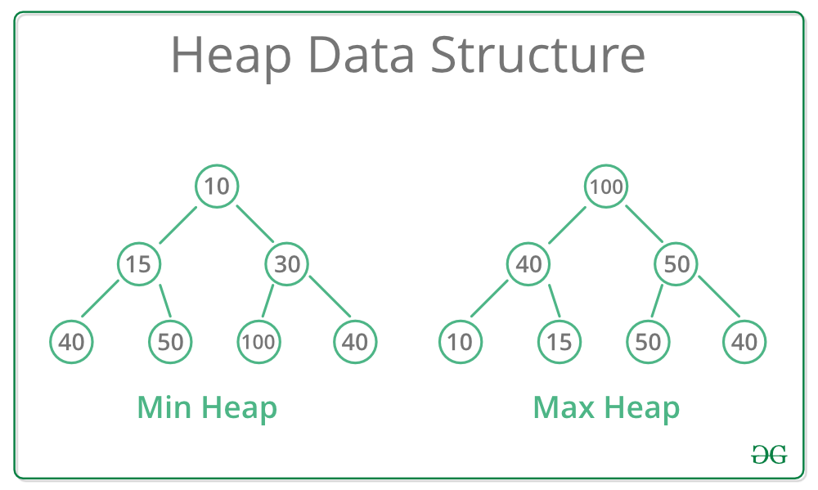

1. Carry out the following operations on the the following heap:
   1. 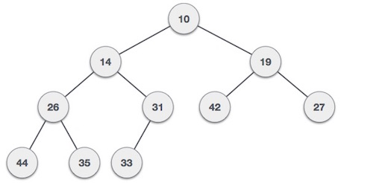Insert key 8, then
   2. Insert key 40, then
   3. Insert key 15, then
   4. RemoveMin, then
   5. Update lastNode with a key 16



1. Carry out the following operations on the following Max heap:
   1. Insert key 90, then
   2. Insert key 70 (Is it possible?), then
   3. Insert key 15, then
   4. RemoveMax,
   5. Then update LastNode with a key 110
2. What is the time complexity of the heap sort algorithm? Explain the complexity of each phase.
3. Construct a max heap from the following keys saved in array:

[40 20 30 10 15 20 25 5 9 10 12]

1. Draw the hash table given that its 17, with collisions resolved by separate chaining. The compression function is h(k) = k mod 17. Assume that the entered keys are: 5, 6, 8, 10, 23, 67, 16, 19, 34, 56, 34, 55, 88, 102, 77, 99, 90, 23.
2. Draw the 11-entry hash table that results from using the hash function, h(i) = (3i+5) mod 11, to hash the keys 12, 44, 13, 88, 23, 94, 11, 39, 20, 16, and 5, assuming collisions are handled by chaining
3. For the following hash table, assume that we use leaner probing, show where the following keys can be inserted: 23, 66, 34, 60. How many probes in each case?

1. Work the binary search algorithm searching for the value 30 in the following list:

[1 3 5 6 8 10 15 20 25 30 35 40 44 50 55 60]

* 1. How many steps you need to find the target?
  2. What is the time complixity of that algorithm?
  3. Express the algorithm in psedocode.

1. What is the in order traversal of the following binary search tree?

1. For the binary search tree shown in the previous question, draw the search pass to find the key 76 and the pass to find 22. Then draw the tree when removing the key 32.
2. For the binary search tree shown in the previous question, show how to insert an entry with key 77.
3. Write the recursive algorithm that search for a key in a binary search tree. What is the time complexity of that algorithm?